# Combine the abilities and work experiences with the correct description:

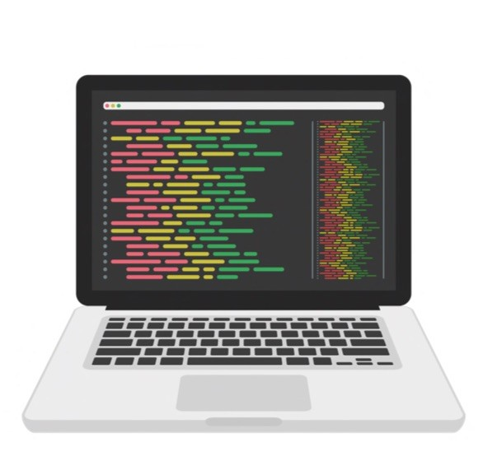

10

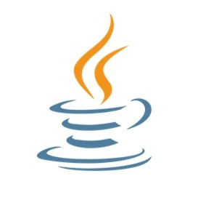

and web

* 1. Python
  2. Experience with databases
  3. Knowledge of algorithms
  4. Strong teamwork skills
  5. Familiarity with web development

( ) A programming language often used in data analysis development.

( ) The ability to work effectively with others to achieve a common goal. ( ) Understanding of step-by-step procedures used to solve problems in computer programming.

( ) Experience in working with organized sets of data, usually in management systems like SQL or NoSQL.

( ) Experience in creating websites and applications for the internet, including HTML, CSS, and JavaScript.

# Now it is with you! Imagine that you are in a job interview and create 5 short sentences talking about yourself, your abilities or work.

1.

2.

3.

4.

5.

____________________________